Application User Flow – Step-by-Step
Step 1: Access the Application
- Open the PayOps application.
- On the landing page, click on the Get Started / Login option highlighted in the red box.
- Proceed with the required authentication details to access the application.
- Once successfully logged in, the user will be redirected to the application dashboard.
Red Mark: The red box highlights the Get Started/Login option, which is the entry point to access the application

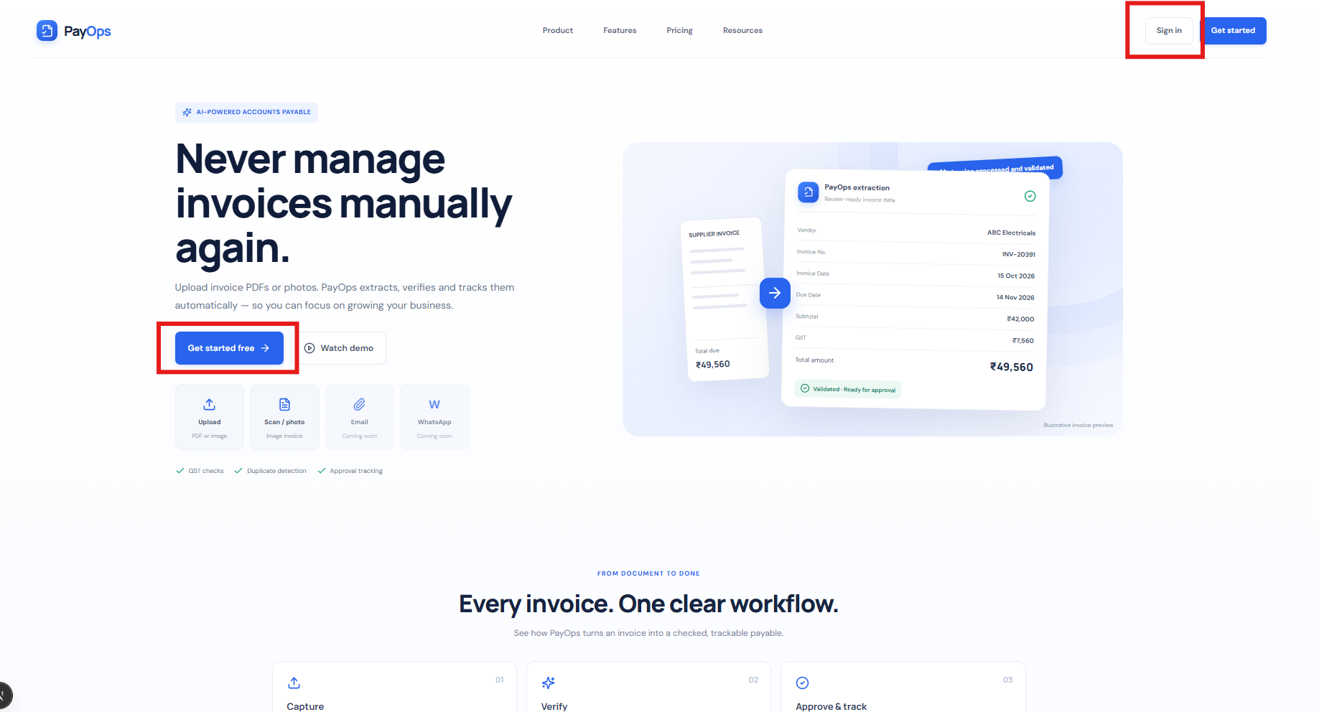
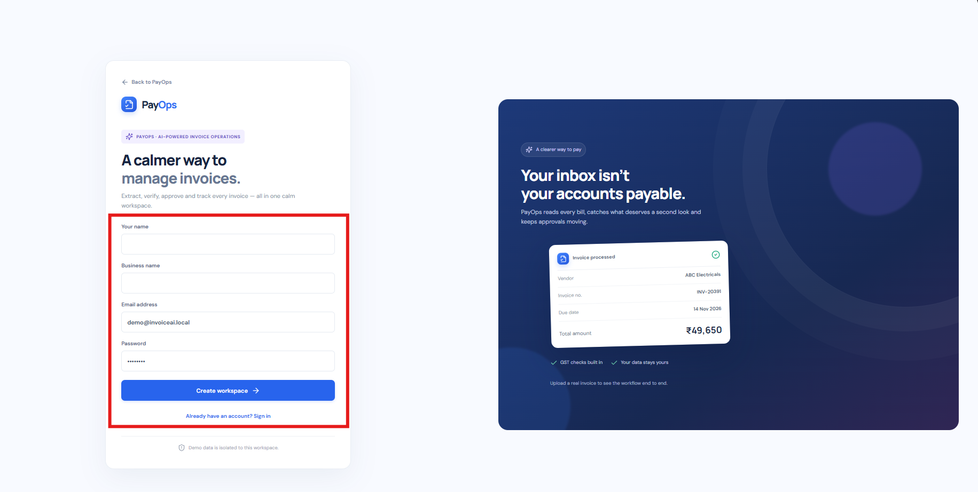
Step 2: Access the Dashboard
- After logging in, the user is redirected to the Dashboard.
- The dashboard provides an overview of invoice-related information and key business metrics.
- The user can navigate through different modules using the left-side navigation menu.
- The red highlighted area on the top-right indicates the notification/activity section, where users can view relevant updates or notifications.
- The highlighted action button can be used to perform the available dashboard action.
Red Mark: The red boxes highlight the notification/activity area and the relevant dashboard action button.

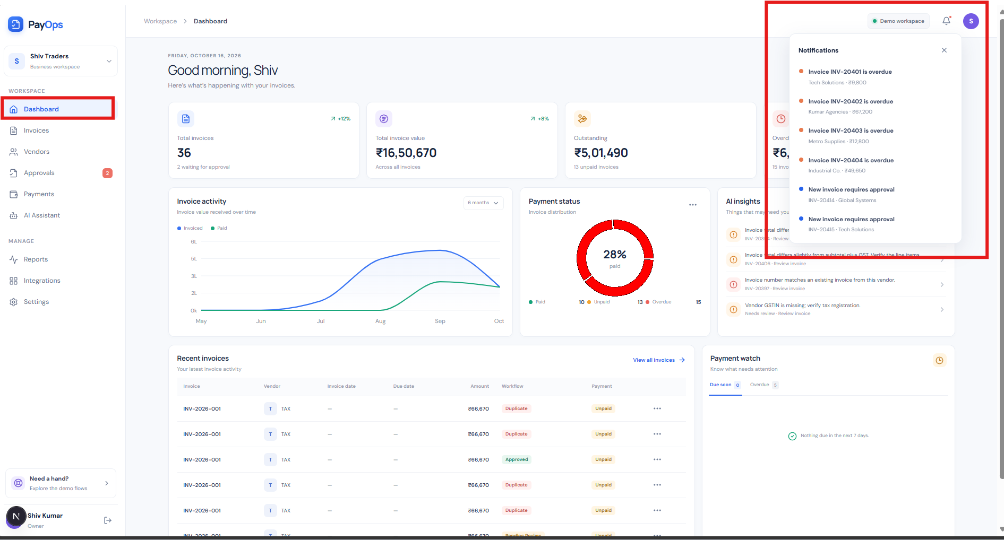
Step 3: Upload Invoices
- From the Dashboard, navigate to the Invoice Upload option.
- Select and upload the required invoice document(s).
- The uploaded invoice is submitted to the application for further processing.
- Once the invoice is successfully uploaded, it proceeds to the AI-based extraction process.
Red Mark: The red highlighted area indicates the invoice upload/action option.

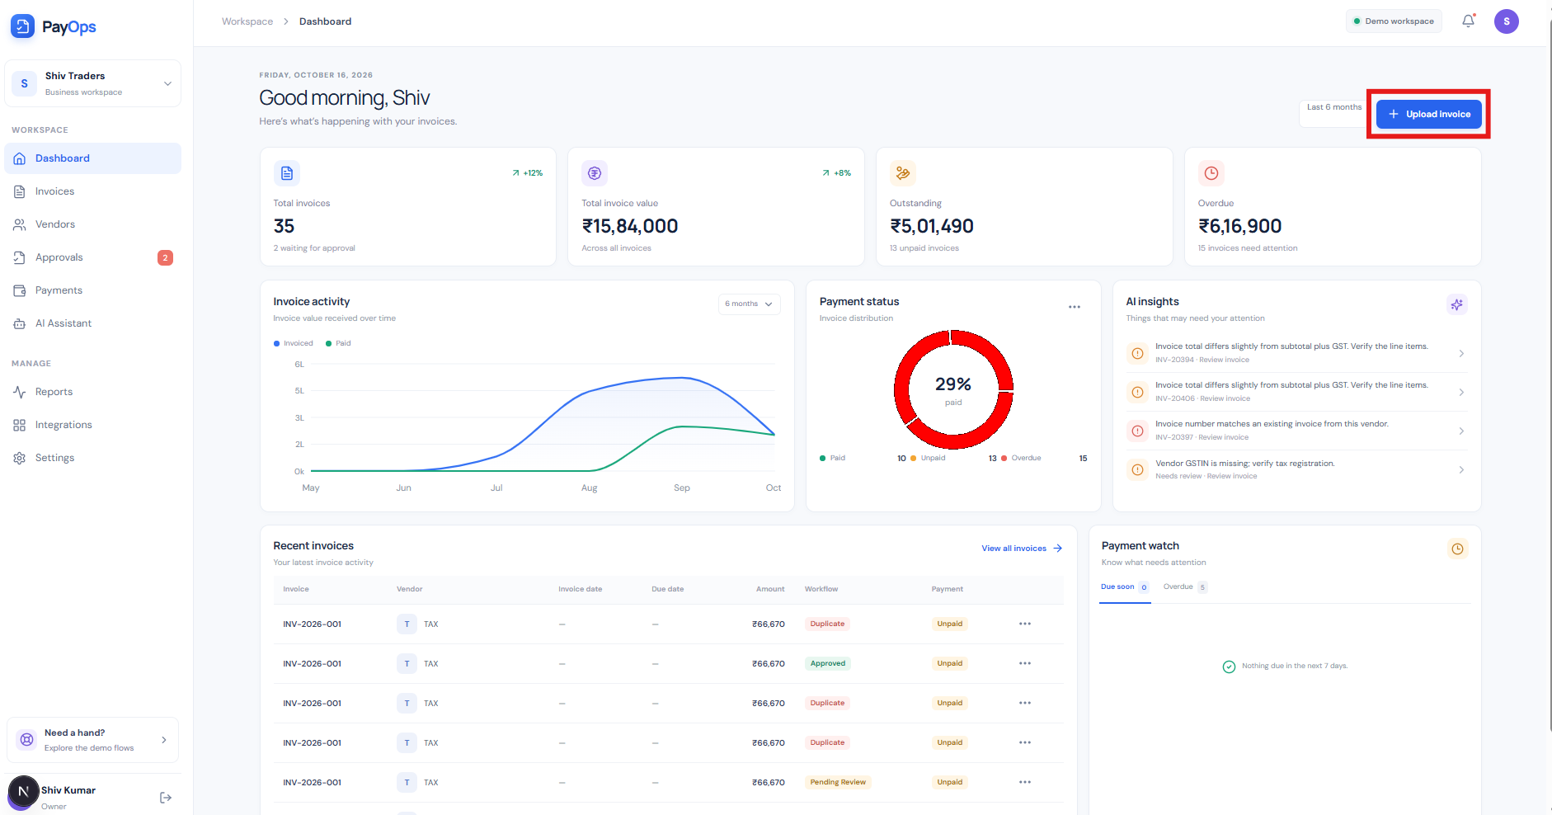
Step 4: AI-Based Invoice Extraction
- After the invoice is uploaded, the application uses AI-based extraction to process the invoice.
- Relevant information is automatically extracted from the uploaded invoice.
- The extracted information is then made available for review and further processing.
- This reduces the need for manual data entry and allows users to validate the extracted invoice details.
Red Mark: The highlighted section indicates the extracted invoice information/details generated by the application.

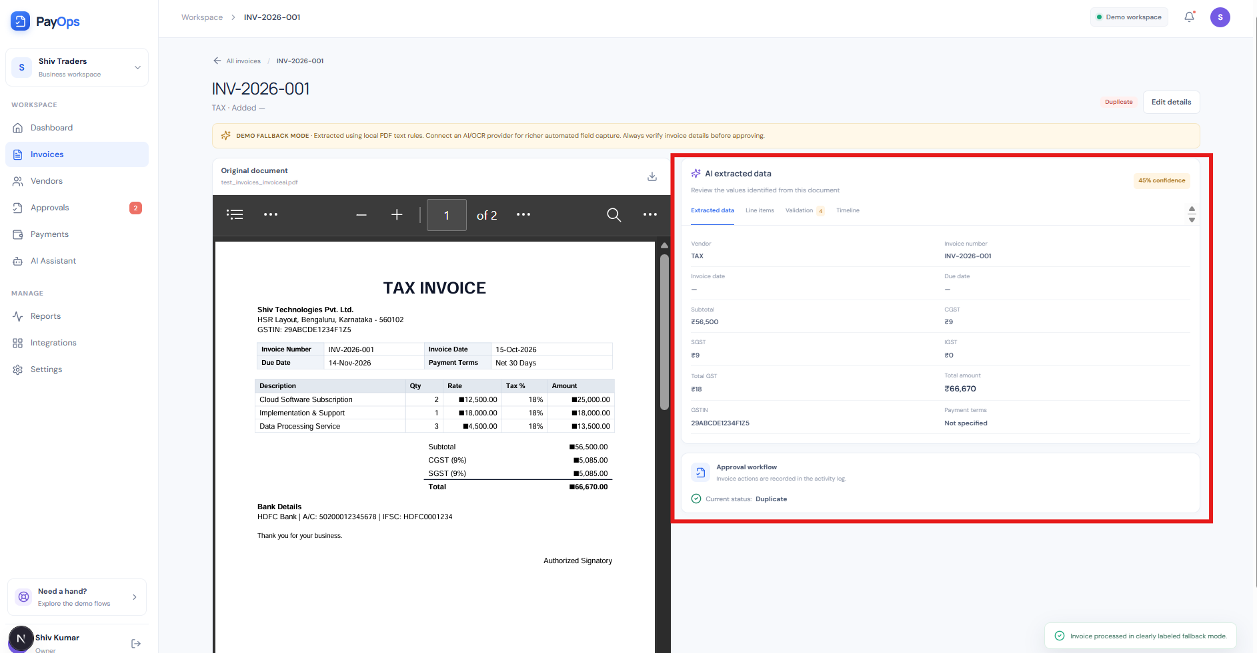

Step 5: View and Manage Invoices
- Navigate to the Invoices section from the left-side navigation menu.
- The invoice listing page displays the invoices that have been uploaded and processed.
- Select an invoice to open its detailed view.
- The invoice detail screen allows the user to review the original invoice along with the AI-extracted information.
- Users can review the extracted details and perform the available invoice-related actions.
Red Mark: The red boxes highlight the Invoices module and the invoice details/extracted information section.

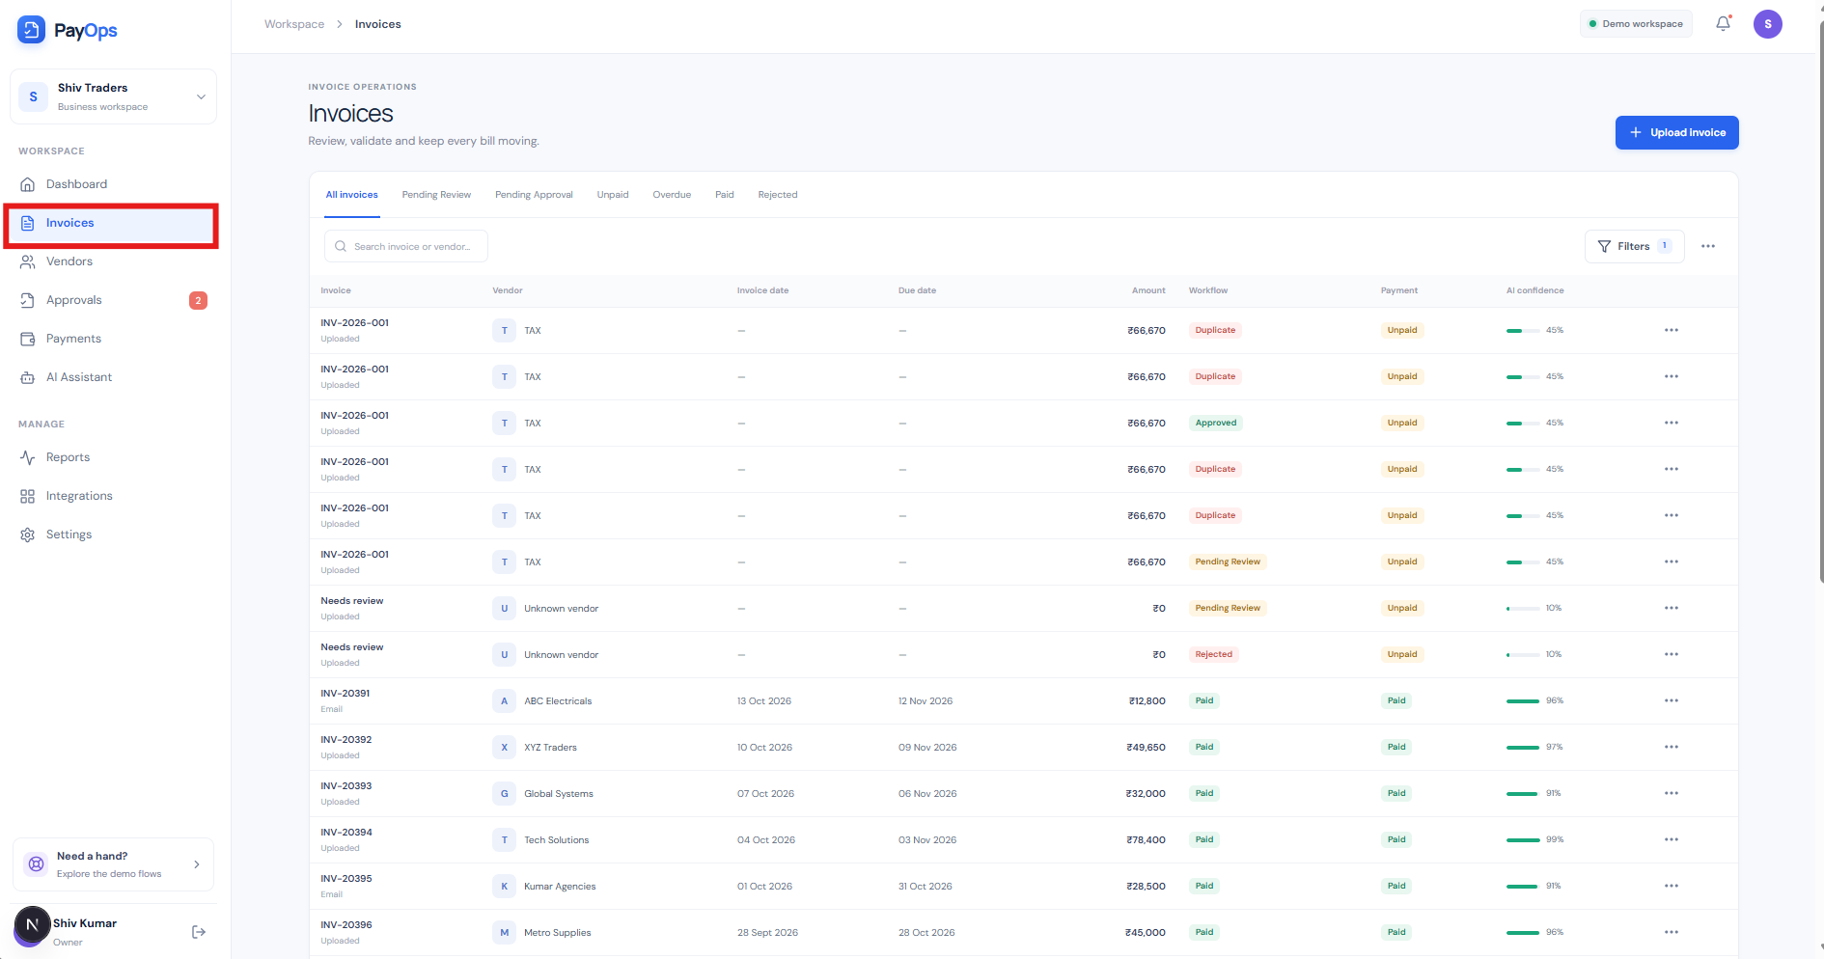
Step 4 – Vendors
Navigate to Vendors to view and manage vendor-related information. The red box highlights the Vendors module.
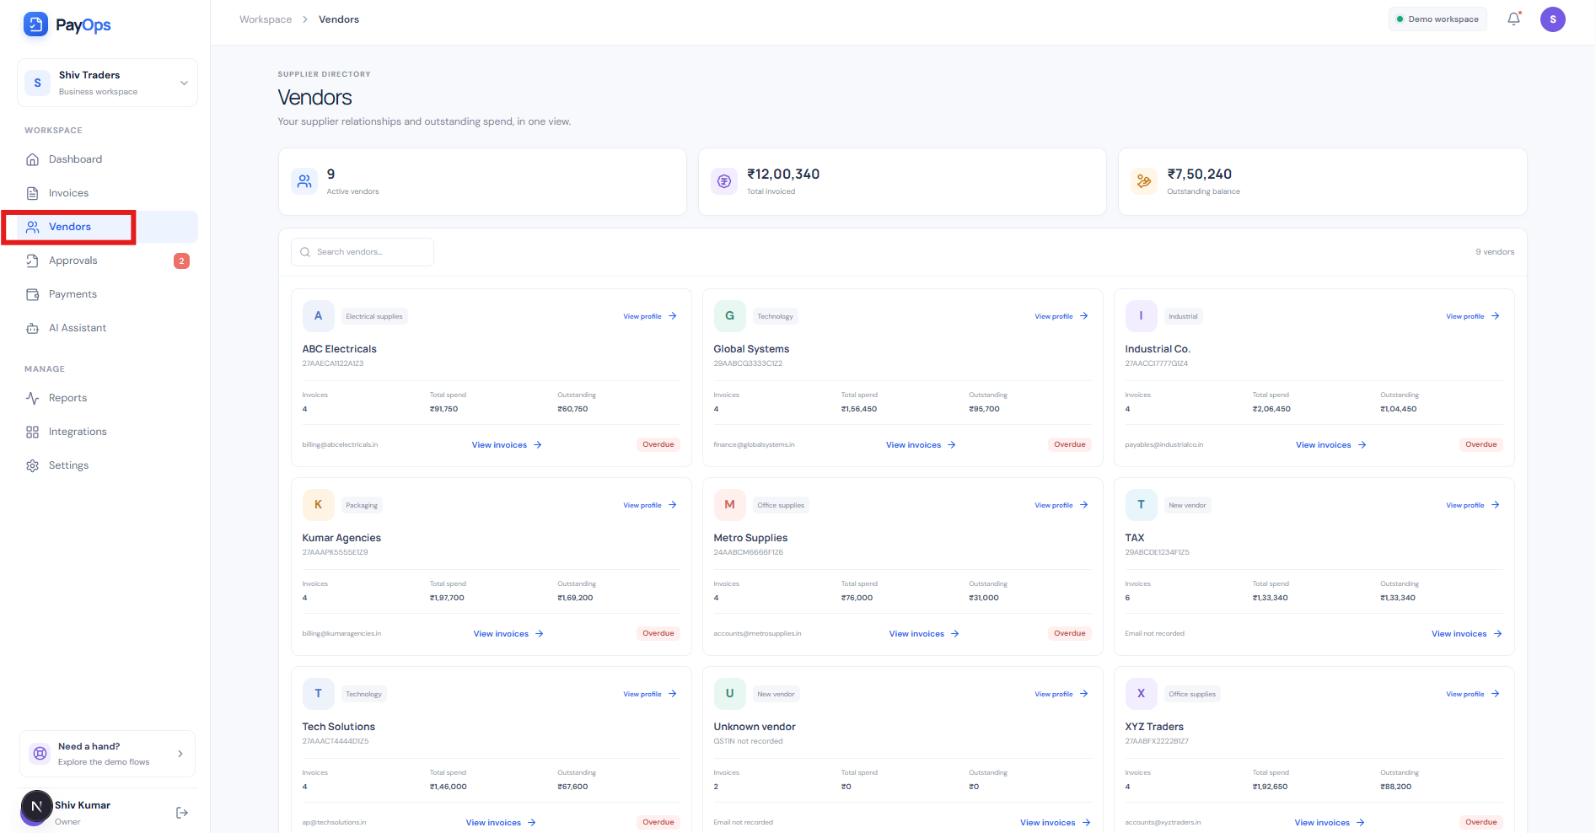
Step 5 – Approvals
Navigate to Approvals to review pending requests and perform the available approval actions. The red box highlights the Approvals module.

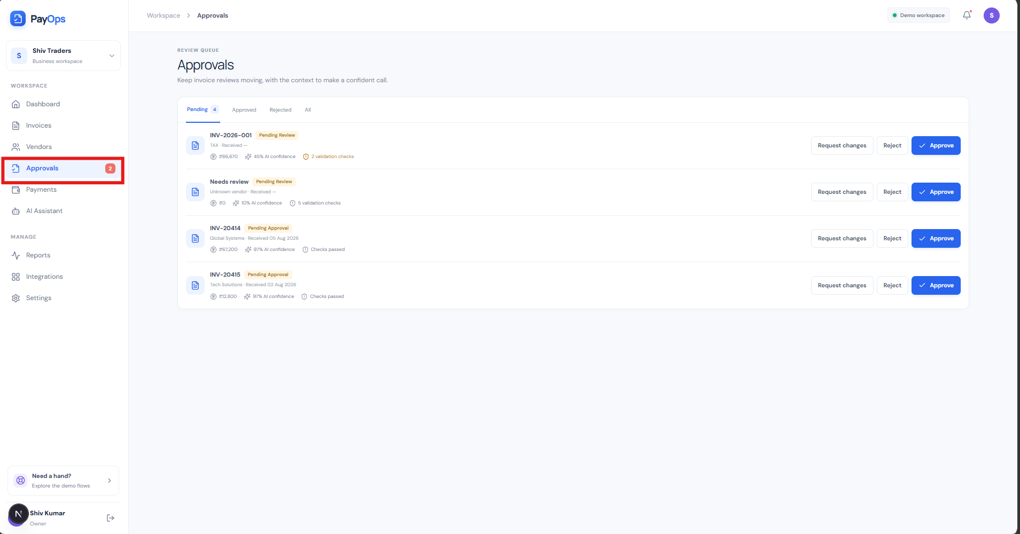

Step 6 – Payments & AI Assistant
Navigate to Payments to review payment records and status. The AI Assistant can also be used to interact with the system through natural-language queries. The red boxes highlight these areas.
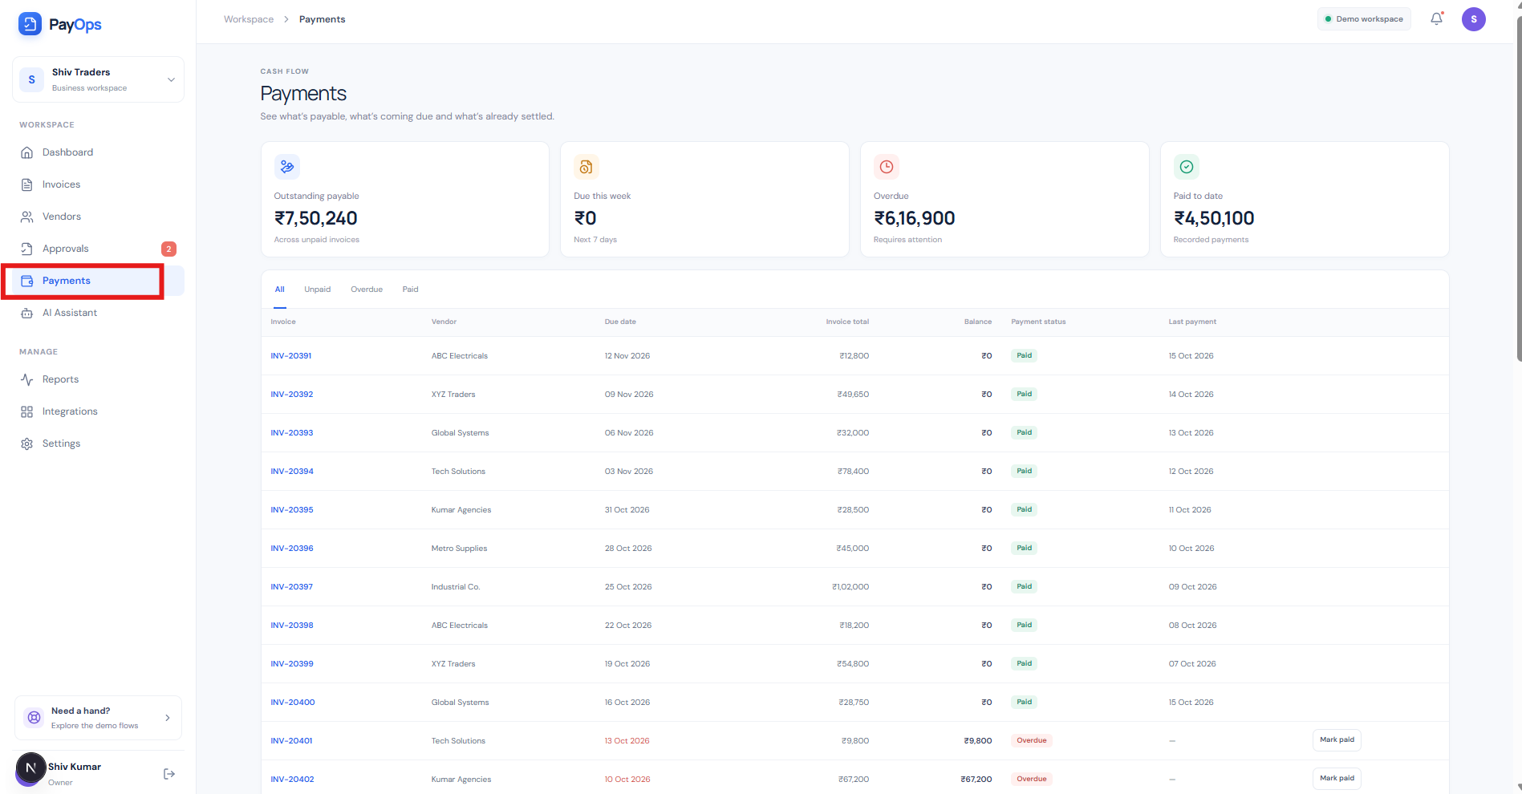

Step 6: AI Assistant
- Navigate to the Payments below section from the left-side navigation menu.
- The application provides an AI Assistant to help users interact with the invoice/payment information using natural-language queries.
- Users can enter their questions or requests in the AI Assistant input area.
- The AI Assistant processes the user's query and provides the relevant information or response.
- This enables users to quickly retrieve required information without manually navigating through multiple records or screens.
Red Mark: The red highlighted area indicates the AI Assistant interface, where users can enter their queries and interact with the AI Assistant.
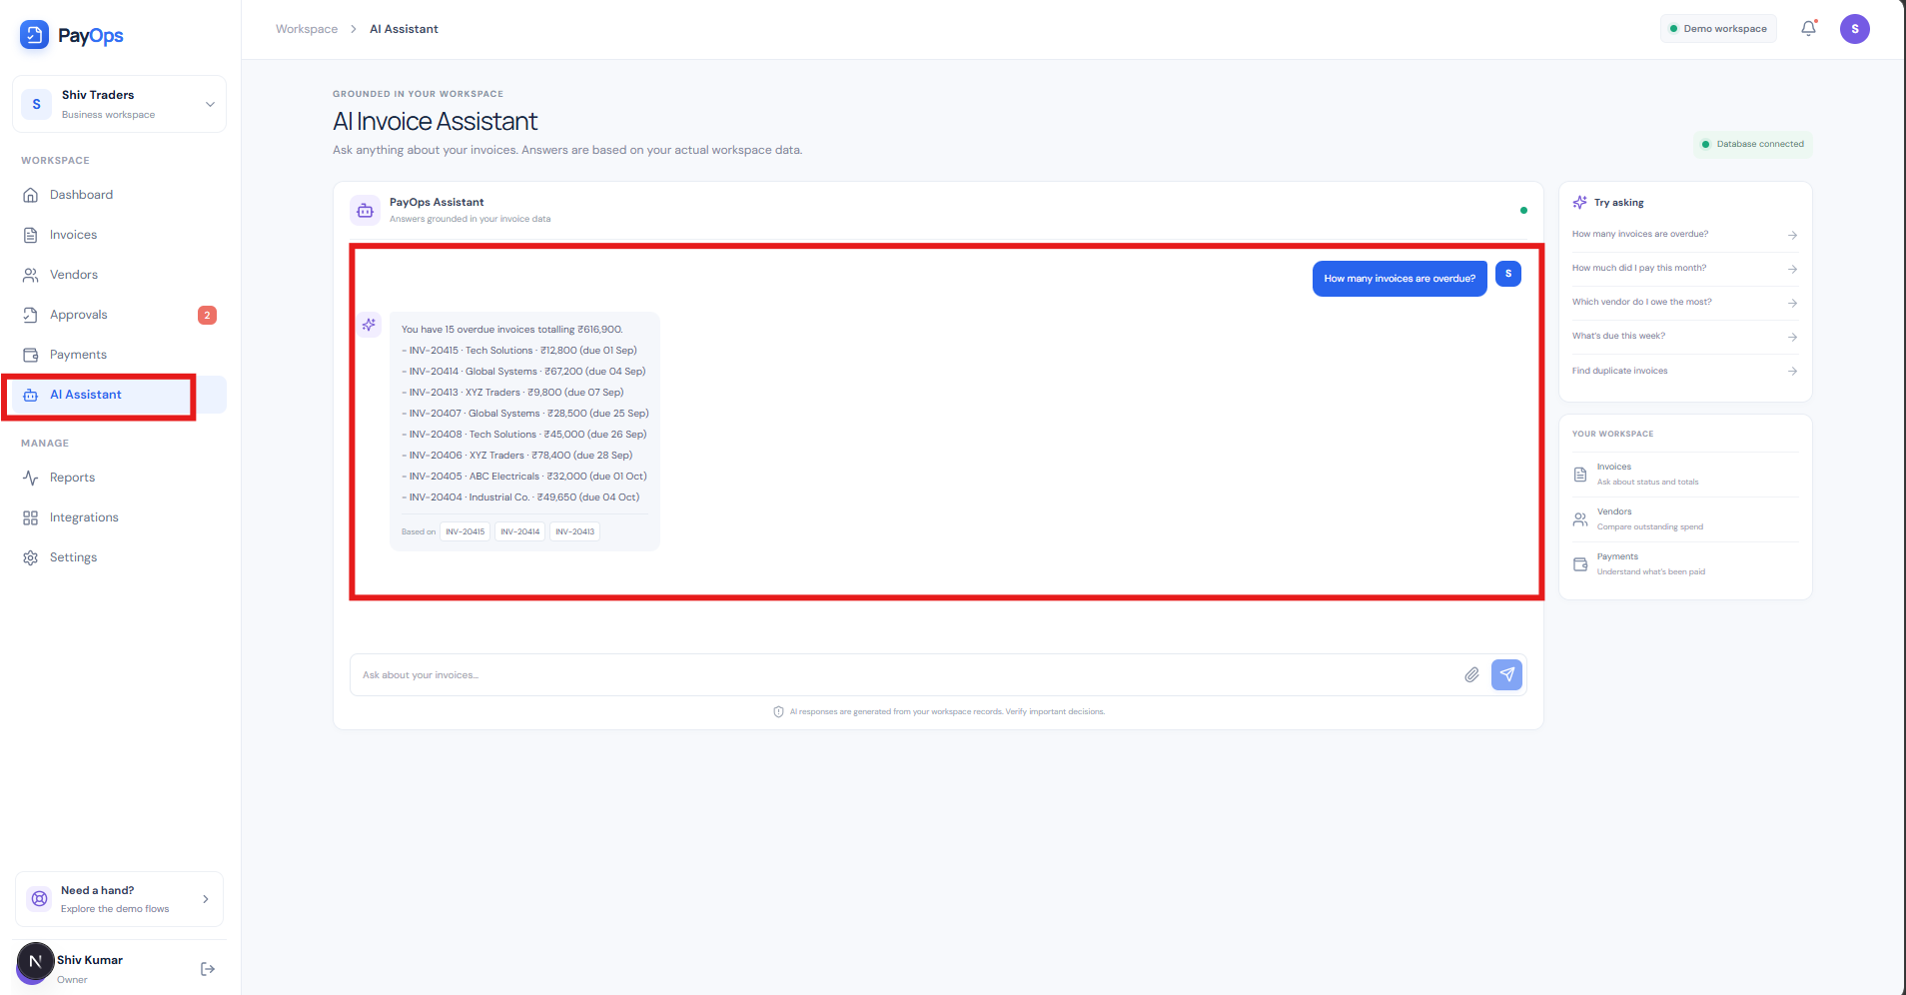
Step 7 – Reports & Integrations
Navigate to Reports to view business metrics, invoice-related summaries, and graphical reports. The Reports section provides a consolidated view of key information, helping users monitor business activities and analyze the available data.
Navigate to Integrations to view and manage the different third-party and external system integrations available within the application. The Integrations section provides a centralized view of the systems/services that can be connected with the application.
Users can:
- View the available integration options supported by the application.
- Review the current integration/configuration status of each available service.
- Access the respective integration configuration where applicable.
- Connect or configure external services to enable data exchange and interoperability with the application.
- Manage multiple integrations from a single centralized interface, instead of configuring them separately across different modules.
- Use these integrations to support the overall invoice, payment, and business workflow by allowing the application to communicate with connected external systems.
Red Mark: The red highlighted boxes indicate the Reports and Integrations modules in the left-side navigation menu. The Integrations screen displays the available integration options as individual cards, allowing users to view and manage the supported integrations from one place.
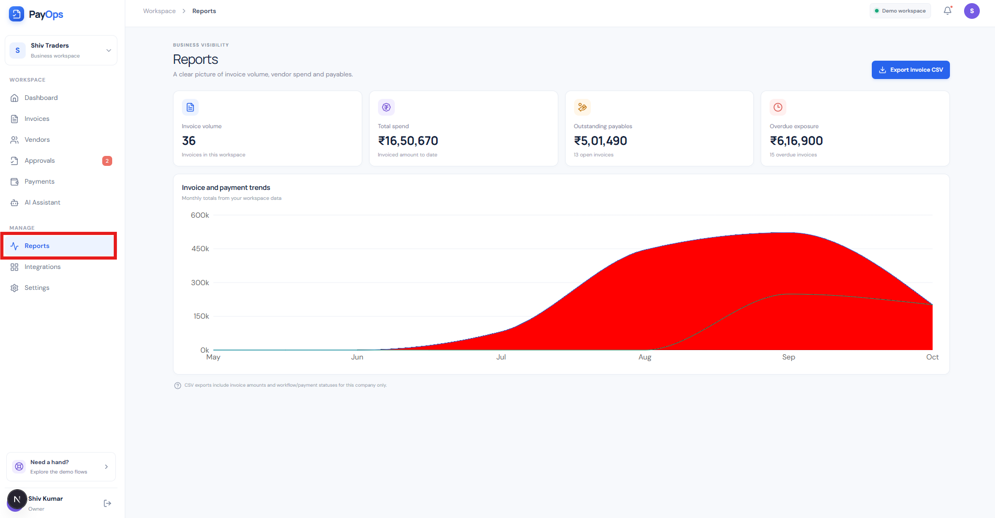
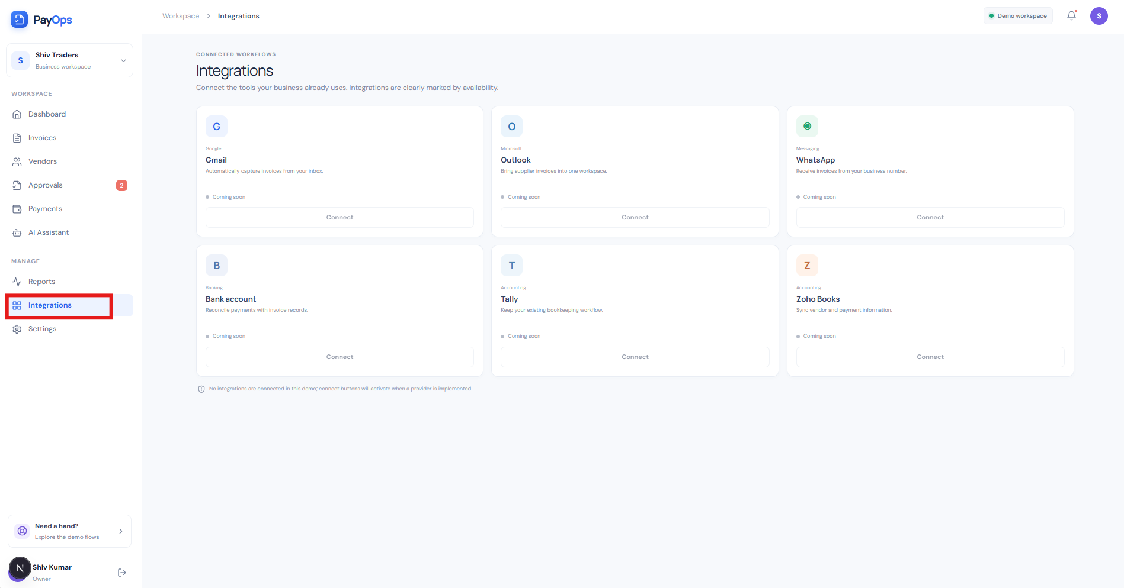

Step 8 – Settings
Navigate to Settings to review and manage available application configurations. The red box highlights the Settings module.
